Tricks in Movies (Now You See Me)
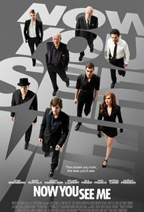
Many movies involving magic tricks have been made over the years. People enjoy these movies because they like to be tricked, it is very intriguing for people to see something that, according to their brains, should be impossible. One of the most recent movie involving magic tricks is Now You See Me, and its sequel Now You See Me 2. The movie revolves around a group of magicians, called the four horsemen, as they try to outsmart a group of detectives, all while planning their next breathtaking shows. The movie contains many mind-numbing tricks, which are all possible to be performed by professional magicians, this was done to create a sense of realism regarding the movie.
The movie opens with one of the main characters, Danny Atlas, performing a trick on a girl in the street. Danny tells the girl to see one card as he flips through his deck. After he does so he opens the deck towards the girl, with all the cards visible, except for the one the girl allegedly saw. Danny then throws the deck in the air and the card that the girl saw, a 7 of diamonds, appears in lights on a nearby skyscraper. When the viewer participates in this trick, they will, too, see the 7 of diamonds. This is because the cards are positioned in such a way that the 7 of diamonds will be visible for just a little longer than the other cards, making that the one that catches your eye. This trick doesn’t have to do with math, it has more to do with making people believe they have a choice in which card they see, when, in reality, the trick was completely controlled by the magician.
The next trick is performed by another one of the main characters, Jack Wilder. He tells a crowd on a ferry that whoever can tell him how he does a spoon-bending magic trick, will get 100 dollars. He does his illusion and a spectator notices that he has multiple other spoons up his sleeve and in his pocket. Jack reluctantly gives the man his money and takes off. The man suddenly realizes that Jack has robbed him of his wallet and watch, and the spoon-bending trick was just a distraction for the real illusion; a clever robbery. This trick involves some math, Jack has to estimate how quickly he has to leave the boat before the robbed man realizes that he has been robbed, he also has to plan out the correct angle in which he robs the man, so that both the spectators and the man himself don’t notice it when it happens.
The movie then cuts to Henley Reaves, another magician. She is performing a trick involving water, chains and flesh-eating piranhas. She is cuffed by her ankles and wrists and is then dropped into a glass box filled with water. In a minute, flesh-eating piranhas will be automatically dropped into the box of water. Henley easily gets one cuff lose but struggles with the others, as they appear to be stuck in the roster beneath her. Panic arises as she struggles to escape. She comes above water just in time but the piranhas come falling into the box and panic rises as Henley struggles is dragged back down by the force of the falling water. The water quickly turns red and people stand by in horror as it appears that she was eaten alive, only for her to reveal herself mere seconds later. This trick involves calculating how long it will take for the piranhas to start attacking Henley, and she has to get out of the water at just the right moment to avoid being eaten alive. So this trick involves both math and distraction, just like the one with Jack, just on a larger scale.
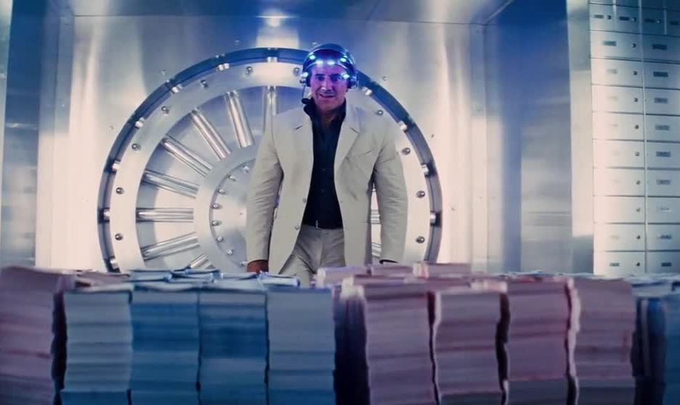
The following trick shown takes place a year later. The four main characters; Danny, Merritt, Henley and Jack are now a group act and they call themselves the ‘Four Horsemen’. They are performing on a large stage in Las Vegas and they announce that they are going to rob a bank. A random seat number is chosen and the bank of the person who is sitting on that seat will be robbed. The man happens to be a Frenchman. While the audience is distracted by the group thanking their benefactor Merritt hypnotizes the Frenchman. The man is given a helmet by the Horsemen. The man has to take a card, sign it, and put it in his pocket. The man is then led into a contraption and the Horsemen count to three before a button is pushed and the contraption closes. The Frenchman is now shown to be in the vault of his bank in Paris with around 3 million Euros in cash on pallets in front of him. He is then told to press a button on his helmet which causes a vacuum to suck all the cash from the to the venue in Vegas. People are surprised by the cash floating around the room. Meanwhile employees of the French back arrive in the vault, only to find all the cash gone, with just the signed card and the man’s ticket for the show left on the empty pallets. It is later revealed how they did the trick. Below the contraption that was supposed to ‘transport’ the Frenchman is a replica of the vault in Paris. The audience was made to believe that the seat number chosen was completely random, when, in reality, it was rigged by the Horsemen. It is also revealed that the Horsemen had been following and studying the Frenchman for a long time, they hypnotized him and he only needed to be ‘activated’ on stage. It is also explained that the horsemen did steal the money, they just didn’t rob the bank. They targeted the truck that was transporting the money to the French bank; they climbed inside the truck before the money was loaded on and during the trip to the bank they hypnotized the truck’s crew and changed the money for flash paper. The flash paper burned up without a trace and the only things left were the card with the man’s signature, which they had acquired through his credit card, and the ticket of the show. This trick involves planning ahead on an extreme level. Calculating the exact time of the ‘robbery’ and the burning of the flash paper, also calculating the correct time to rob the truck, influence the man and many other aspects. This trick was based around, timing, planning and distraction, some of the main factors of magic.
The next scene involves multiple tricks. The Horsemen have been arrested for the robbery and are being held in separate interrogation room. Henley has managed to balance the chair opposite her on one leg. This involves math in a very clear way. The correct angle and balance of the chair has to be calculated in order to get it to stay upright when balanced on just one leg. Another trick is performed by Danny. He is being interrogated by FBI agent Dylan Rhodes and Alma Dray, a French Interpol agent. Danny claims that they will never arrest them because then they would admit they believe in magic. Danny then hits the desk and the cuffs on his hand move to Dylan’s, cuffing him. He then tells Alma to look in her coke can, which contains the keys to the cuffs. Danny grabs Dylan’s phone before the coke from the can reaches it and quickly switches it with an identical one, which has a tracking device on it. This trick takes perfect timing, estimation of people’s actions, deception and coordination.
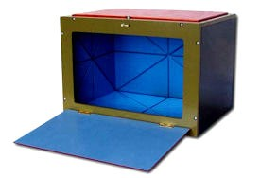
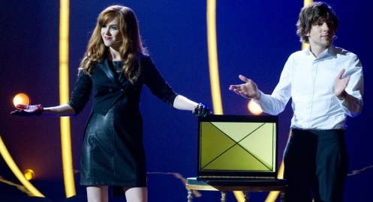
The Horsemen’s next show consist of them explaining some of magic’s oldest tricks. Including the ‘empty box mirror trick’. They put a live rabbit in a seemingly normal box. They distract the audience and when they open the box, the rabbit seems to have vanished into thin air. Henley then takes a mirror out of the box, revealing that the rabbit is still behind it. This trick involves calculating the angle at which the mirror should be positioned in order to make the box look empty, but it can’t be visible to anyone in the audience from any perspective. The final trick of the night is another robbery, but this time they rob their benefactor: Arthur Tressler. All the people in the audience were victims of Hurricane Katrina and they were all insured by Tressler Insurance. The audience members are told to wave their flashlight over their current bank balance, which they were asked to write down during intermission, and the numbers went up for each of them while Arthur’s bank balance went down, the Horsemen repaid the people who weren’t helped after Hurricane Katrina the amount they were denied by the insurance company. When asked how they did it, they refer back to a scene on their private jet, where Danny tried to ‘read’ Arthur like Merritt can, and when he gets it wrong Arthur reveals personal information like his first pet and his mother’s maiden name, which could be used to get into Arthur’s bank account and rob him. This trick doesn’t involve math as much but it does involve deception and distraction for both the audience and Arthur himself, who had been working with the Horsemen for a year.
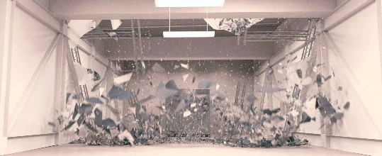
Their final trick happens farther along the movie. The Horsemen try to steal a safe from a warehouse. The police know this and follow them, thinking they are finally catching up to them. The Horsemen announce one last show, where the safe appears to be going. When the truck arrives at the venue of the show the police open the safe to find that it isn’t the real safe. The real safe was still in the warehouse, which appeared to be empty when the police was there but in reality, there was a large mirror, like with the rabbit in the box, making the room appear empty. Which, definitely on this scale, needs to be thought out perfectly. The timing of the arrival of the police, the angle of the mirror, the distance of the mirror form the entrance of the room, which had to be far enough for the police to believe the room was empty without them walking into the mirror.
In conclusion, there are many movies with magic tricks in them. Now You See Me is just a single example. After analyzing the tricks used in this movie it has become clear to me that many tricks used in this movie use math in some way, whether it’s balance, angles or estimation math will always find a way to worm itself into a magic trick. However, many other factors play important roles in tricks like deception and illusion, but without the use of math, the tricks wouldn’t be the way they are now.

